ITDI110 – Object-Oriented Programming & Software Development.

Groupe Name: Georges TAUANEARU & Kenny DONNA

Checkpoint 1 – Requirements Analysis & OOP System Design

Project: Online Job Application & Recruitment System.

Problem description
Many companies still handle job applications in a slow and messy way — using paper forms, emails, or spreadsheets. This makes it hard to keep track of applicants, job postings, and interview schedules. Applicants often don’t know the status of their application, and HR staff spend too much time organizing everything manually. As a result, recruitment processes are often inefficient, due to manual handling of job applications, candidate shortlisting, and interview scheduling. This leads to delays, miscommunication, and difficulty tracking applicant progress.
Our system aims to digitize and streamline recruitment workflows. An online recruitment system solves this by putting everything in one place: job vacancies issued by the Human resource manager and configured to be available online within a certain period of time. This will allow the job seekers to apply online. The applicants apply to the job vacancies online by filling in the Application form online and submitting the job application requirements Softcopy of (1-Personal Information: National ID Card, Birth Certificate, Passport, Medical Report, 2-Qualification Information: Tertiary Certificate, Diploma, Degree, Master, Doctorate, 3-Curriculum Vitae: Updated version of CV, 4-Referee: Reference Letter from previous employer administrator and approved community authorities.
The system also generates a benchmarking scheme to allow each job applications to be assessed with allocated marks. The system ranks the highest to the lowest the results of job applications. And provide the names of the first for example 5 or 10 best candidates for the interview process, interview scheduling, and status updates. It makes the hiring process faster, clearer, and easier for both applicants and HR staff.

Project objectives
- Provide a browser-based platform for job seekers to apply online and recruitment.
- Enable HR/admin users to post job vacancies and manage applications.
- Allow applicants to submit applications and track their application status. (Submitted, shortlisted, interviewed, hired, rejected)
- Support interview scheduling and candidate shortlisting.
- Ensure secure and organized storage of applicant data.
- Improve efficiency and transparency in recruitment.
- Coordinate score of application based on agreed scoring rubrics (to be determined)
- Coordinate score of interviews based on application content (to be determined)
- Communicate update of the process to the candidate
- Coordinate interviewees and interviewers in a consensus manner
- Coordinate recruitment board to deliver the final decision to the applicant
- Coordinate communication of the final decision to the applicant

Target users
  - Job Seekers (students, graduates, professionals)
  - HR/Admin Staff (recruiters, interviewers, hiring managers)
  - Organizations (companies, institutions)

Minimum 6 functional requirements
- Job posting - Recruiters can create, edit, and delete job vacancies
- Application submission – Applicants can apply online via forms
- Application tracking – System updates and displays application status
- Interview scheduling – Recruiters can schedule interviews and notify applicants
- Candidate shortlisting – Recruiters can filter and shortlist candidates.
- Search functionality – Recruiters can search applicants by name, skills, or status.

Identification of the main classes/objects

- User (base class)
- Properties: userid: number; name: string, email: string
- Methods: login(), logout()
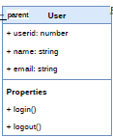

- Applicant (extends User)
- Properties: applicantid : number ;resume : private-string, phone: number
- Methods: getNationalID(), getPassport(), getBirthCertificate, getDiploma(), getBachelor(), getMaster(), getReferee(), submitapplication().
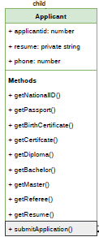

- Human Resource Staff (extends User)
- Properties: hrid : number, name : string, email: string.
- Methods: createJobVacancy(), updateJobVacany(), publishJobVacancy(), deleteJobVacancy, displayJobVacancy(), extendJobVacancy(), republishJobVacancy()
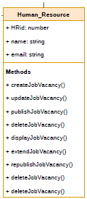

- JobVacancy(base class)
- Properties: jobVacncyID : number, company: string, jobtitle: string; jobdescription : text, responsabilities: text, qualification: string, skills: string, salary: number, benefits: string, work_location: string, app_instruction: string, startdate: date, enddate: date.
- Methods: displayjvdashboard(), approvejvdashboard(), createjvscoresheet(), displayjvonline(), applyjobvacancy(), removejvonline()
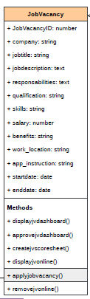

- Application
- Properties: applicationId: number, jobvacancyid: number, applicantid: number.
- Methods: registerapplication(), storeapplication(), countapplication(), scuritunizeapplication(), countapplication().
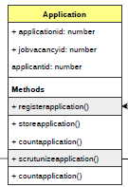
- Recruiter
- Properties: recruiterid : number, position: string, phone: number.
- Methods: getNationalIDvalid(), getPassportvalid(), getBirthCertificatevalid(), getCertificatevalid(), getDiplomavalid(), getBachelorvalid(), getMastervalid(), getrefereevalid(), scrutunizeapplication().
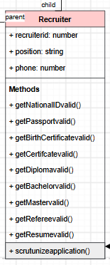

UML Class Diagram
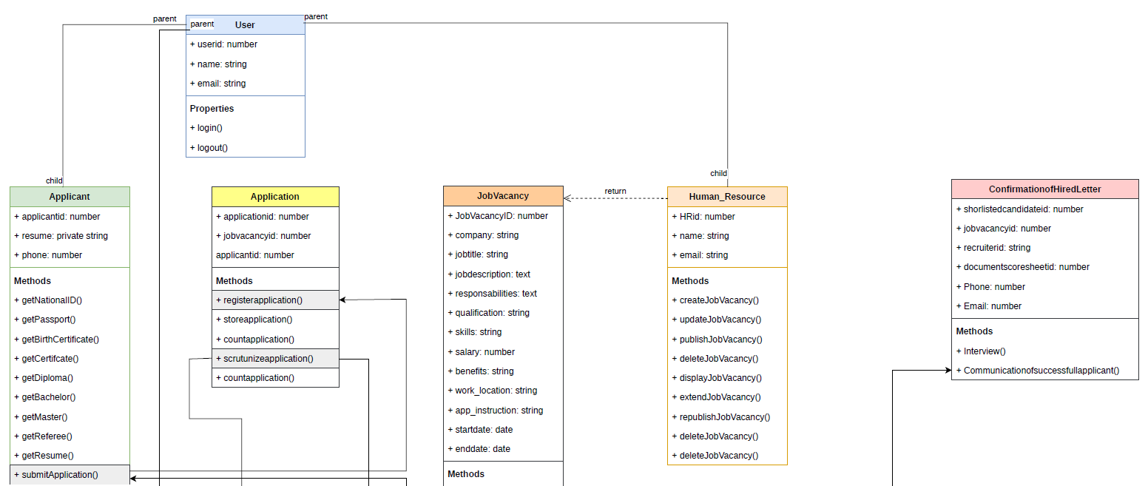

A missing part is to be inserted here please refer to the pdf file for clarification!

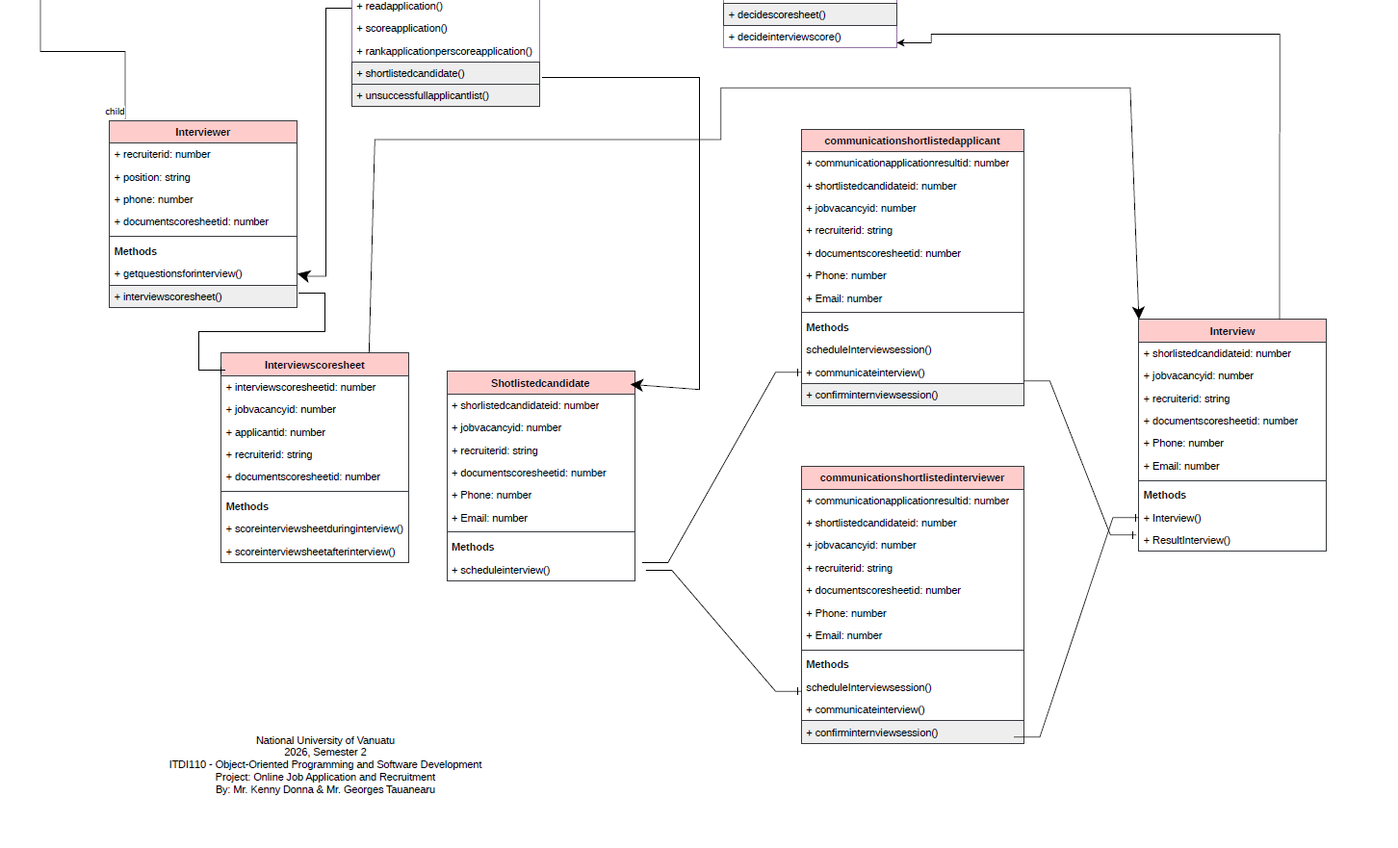

At least one inheritance relationship

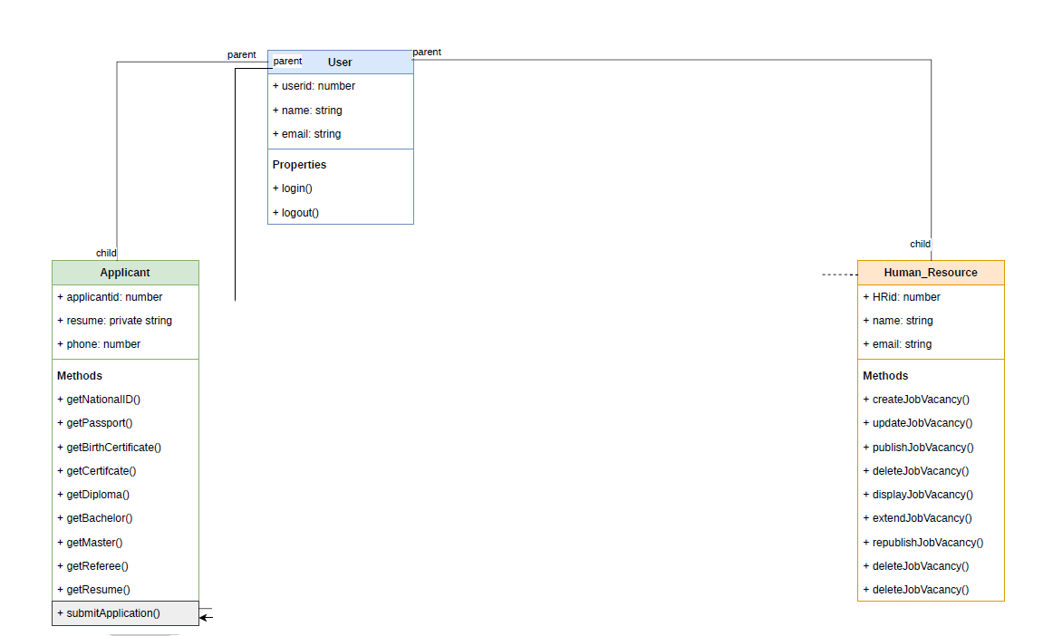

Identification of where encapsulation will be applied
As fare as private properties is concerned:
- Applicant resumes and personal data will be stored as private properties.
- Access controlled via getters/setters to ensure data privacy.

Proposed design pattern - Explanation/justification for the selected pattern
As we can see in the diagram above we have complex objects to create, for instance, organization will come with their requirement so therefore to comply with their requirement will have various types of application.
The appropriate design pattern to gather for that variety is Factory Method.
- Factory Method
  - Problem solved: Complex object creation (e.g., different types of applications or interview objects).
  - Why appropriate: Centralizes creation logic, avoids duplication, and makes it easy to extend new types of job applications later.
Another design pattern as we can see during the process of application State Pattern are to be used because, each application passes from one state to another. And creates other components.
- State Pattern
  - Problem solved: Managing application status transitions.
  - Why appropriate: Encapsulates each status (Submitted, Shortlisted, Interview Scheduled, Hired, Rejected) as a separate class, making transitions explicit and reducing conditional spaghetti code.
For instance if we see carefully, when the application got scored to be successful, then it creates other objects such as shortlistofcandidates etc…
- Observer Pattern
  - Problem solved: Event-driven updates when application status changes.
  - Why appropriate: Decouples the core application logic from dependent modules (notifications, dashboards, analytics). When status changes, observers are automatically notified.

- Mediator Pattern
  - Problem solved: Coordinating interview scheduling among multiple actors.
  - Why appropriate: Provides a central mediator to handle communication between candidate, recruiter, and manager without them directly referencing each other.

Initial JavaScript class structure
javascript
class User {
constructor(userId, name, email) {
this.userId = userId;
this.name = name;
this.email = email;
}
login() { /* ... */ }
logout() { /* ... */ }
}

class Applicant extends User {
constructor(userId, name, email, resume) {
super(userId, name, email);
this.#resume = resume; // encapsulated
}
submitApplication(job) { /* ... */ }
getResume() { return this.#resume; }
}

class Recruiter extends User {
shortlistCandidate(application) { /* ... */ }
notifyApplicant(applicant) { /* ... */ }
}

class Job {
constructor(jobId, title, description, requirements) {
this.jobId = jobId;
this.title = title;
this.description = description;
this.requirements = requirements;
this.status = "open";
}
closeJob() { this.status = "closed"; }
}

class Application {
constructor(applicationId, applicant, job) {
this.applicationId = applicationId;
this.applicant = applicant;
this.job = job;
this.status = "submitted";
this.observers = [];
}
addObserver(observer) { this.observers.push(observer); }
updateStatus(newStatus) {
this.status = newStatus;
this.observers.forEach(obs => obs.notify(this));
}
}

Initial Git/GitHub repository
To perform the Git/GitHub repository:
We create first a repository in GitHub. We use my account gtauanea
The link is here: https://github.com/gtauanearu/ITDI110OnlineJobRecruitment
Then; we open the terminal from Visual Studio Code on the folder that contain the project directory we run the following command:
>git init
>git add .
>git commit -am “Initial commit Checkpoint1”
>git remote add origin https://github.com/gtauanearu/ITDI110OnlineJobRecruitment
>git remote -v
>git push origin master

Checkpoint 2 – Core OOP Development & MVC

Required Implementation
- JavaScript classes and objects
- Constructors
- Properties and methods
- Parameters and return values
- Private fields where appropriate
- Getters/setters
- Encapsulation
- Inheritance using extends and super()
- Selected design pattern
- MVC structure
- HTML/CSS interface
- Forms and user input
- Events and callbacks
- Basic application operations

Expected Result
By the end of Checkpoint 2, the group should be able to demonstrate a working browser-based prototype of the main functions of the application.
Students should also continue making regular and meaningful commits to the project repository.

Part 1 – Project Setup
Online Job Application and Recruitment Sustem Structure /
│
├── index.html
├── app.js
├── style.css
├── model.js
├── view.js
└── controller.js

File 1 – index.html
<!DOCTYPE html>
<html lang="en">
<head>
<meta charset="UTF-8">
<meta name="viewport" content="width=device-width, initial-scale=1.0">
<title>Online Job Application and Recruitment System</title>
<link rel="stylesheet" href="style.css">
</head>
<body>
<header class="header">
<div class="header-content">
<div>
<h1>Online Job Application and Recrutment Prototype</h1>
<p>NUV - ITDI 110 - Semester 2 2026</p>
<p>Designed By Mr. Kenny & Mr. Georges Tauanearu</p>
</div>
<span class="mvc-badge">Checkpoint 2</span>
</div>
</header>

<main class="container">
<section class="dashboard">
<div class="stat-card">
<span>Applicants</span>
<h2 id="totalApplicants">0</h2>
</div>
<div class="stat-card">
<span>Applications</span>
<h2 id="totalApplications">0</h2>
</div>
<div class="stat-card">
<span>Interviews</span>
<h2 id="totalInterviews">0</h2>
</div>
<div class="stat-card">
<span>Interviewers</span>
<h2 id="totalInterviewers">0</h2>
</div>
<div class="stat-card">
<span>Job Vacancies</span>
<h2 id="totalJobVacancies">0</h2>
</div>
<div class="stat-card">
<span>Recruiters</span>
<h2 id="totalRecruiters">0</h2>
</div>
</section>

<section class="main-grid">
<div class="panel">

<h2 id="formTitle">Register User</h2>
<p class="muted">Enter the user information below.</p>
<div class="form-group">
<label for="typeOfUser">Type of User</label>

</div>
<form id="userForm">
<select id="typeOfUser" required>
<option value="">Select Type</option>
<option value ="Applicant">Applicant</option>
<option value ="Recruiter">Recruiter</option>
<option value ="Interviewer">Interviewer</option>
</select>
<div class="form-group">
<label id="userIdlabel">User ID</label>
<input id="userId" type="text" placeholder="e.g. ST001" required>
</div>

<div class="form-group">
<label for="userName">Full Name</label>
<input id="userName" type="text" placeholder="e.g. Mary Tari" required>
</div>

<div class="form-group">
<label for="userEmail">Email</label>
<input id="userEmail" type="email" placeholder="e.g. mary@email.com" required>
</div>
<!--
<div class="form-group">
<label for="gpa">GPA</label>
<input id="gpa" type="number" min="0" max="4" step="0.01"
placeholder="e.g. 3.40" required>
</div>
-->
<button id="registerButton" class="primary-button" type="submit">Register User</button>
</form>

<p id="message" class="message"></p>
</div>

<div class="panel">
<h2>MVC Records at this stage</h2>
<div class="mvc-card"><strong>MODEL Inheritance</strong><span> </span></div>
<div class="mvc-card"><strong></strong><span>1 Parent Model + 3 Child Models</span></div>
<div class="mvc-card"><strong>TOTAL MODELS & METHODS</strong><span></span></div>
<div class="mvc-card"><strong></strong><span>7 Models + 27 Methods</span></div>
<div class="mvc-card"><strong>VIEW</strong><span></span></div>
<div class="mvc-card"><strong>TOTAL VIEWS</strong><span></span></div>
<div class="mvc-card"><strong></strong><span>1 userView +25 Methods</span></div>
<div class="mvc-card"><strong>CONTROLLER</strong><span></span></div>
<div class="mvc-card"><strong>TOTAL CONTROLLERS</strong><span></span></div>
<div class="mvc-card"><strong></strong><span>1 userController + 13 EventControllers </span></div>
</div>

</section>

<section class="records-section">
<h2>Registered Applicants_________________________________________________________</h2>
<div id="applicantRecords" class="user-records">
<div id="emptyApplicantMessage" class="empty-message">
No applicant registered yet.
</div>
</div>
<h2>Registered Recruiters_________________________________________________________</h2>
<div id="recruiterRecords" class="user-records">
<div id="emptyRecruiterMessage" class="empty-message">
No recruiter registered yet.
</div>
</div>
<h2>Published Job Vacancies</h2>

<div id="jobVacancyRecords">

<div
id="emptyJobVacancyMessage"
class="empty-message">

No vacancy published yet.

</div>
</div>

<h2>Registered Applications_________________________________________________________</h2>

<div id="applicationRecords">

<div
id="emptyApplicationMessage"
class="empty-message">

No applications submitted yet.

</div>

</div>

</div>

<!-- NEW SECTION: Registered Applications Assessed -->

<h2>Registered Applications Assessed_________________________________________________</h2>
<hr>
<div id="assessedApplicationRecords">
<p id="emptyAssessedApplicationMessage" class="empty-message">No assessed application yet.</p>
</div>

<h2>Registered Applications Shortlisted for Interview____________________________________</h2>
<hr>
<div id="assessedApplicationRecords">
<p id="emptyAssessedApplicationMessage" class="empty-message">No application shortlisted yet.</p>
</div>

<h2>Registered Interviewers_________________________________________________________</h2>
<div id="interviewerRecords" class="user-records">
<div id="emptyInterviewerMessage" class="empty-message">
No interviewer registered yet.
</div>
</div>

<h2>Successfull Applicants_________________________________________________________</h2>
<div id="interviewerRecords" class="user-records">
<div id="emptyInterviewerMessage" class="empty-message">
No successfull applicant registered yet.
</div>
</div>

</section>
</main>

<script src="model.js"></script>
<script src="view.js"></script>
<script src="controller.js"></script>
<script src="app.js"></script>
</body>
</html>

File 2 – app.js

const view = new UserView();

const controller = new UserController(view);

File 3 – style.css
* {
box-sizing: border-box;
margin: 0;
padding: 0;
}

body {
font-family: Arial, Helvetica, sans-serif;
background: #f4f7fb;
color: #1f2937;
line-height: 1.6;
}

.header {
background: #163a5f;
color: white;
padding: 24px 20px;
}

.header-content {
max-width: 1100px;
margin: auto;
display: flex;
justify-content: space-between;
align-items: center;
}

.mvc-badge {
background: white;
color: #163a5f;
padding: 8px 14px;
border-radius: 20px;
font-weight: bold;
}

.container {
max-width: 1100px;
margin: 28px auto;
padding: 0 20px;
}

.dashboard {
display: grid;
grid-template-columns: repeat(2, 1fr);
gap: 15px;
margin-bottom: 22px;
}

.stat-card,
.panel,
.student-card {
background: white;
border: 1px solid #e5e7eb;
border-radius: 10px;
padding: 20px;
box-shadow: 0 3px 8px rgba(0, 0, 0, 0.05);
}

.stat-card span,
.muted {
color: #6b7280;
}

.stat-card h2 {
color: #163a5f;
font-size: 28px;
}

.main-grid {
display: grid;
grid-template-columns: 2fr 1fr;
gap: 22px;
}

.form-group {
margin: 15px 0;
}

label {
display: block;
font-weight: bold;
margin-bottom: 5px;
}

input,
select {
width: 100%;
padding: 11px;
border: 1px solid #d1d5db;
border-radius: 6px;
}

.primary-button {
width: 100%;
padding: 12px;
border: none;
border-radius: 6px;
background: #163a5f;
color: white;
font-weight: bold;
cursor: pointer;
}

.mvc-card {
display: flex;
justify-content: space-between;
padding: 14px;
margin-top: 12px;
border: 1px solid #e5e7eb;
border-radius: 7px;
}

.rule-card {
display: flex;
justify-content: left;
padding: 10px;
margin-top: 6px;
border: 1px solid #163a5f;
border-radius: 7px;
}

.records-section {
margin-top: 28px;
}

.user-records {
margin-top: 12px;
display: grid;
grid-template-columns: repeat(3, 1fr);
gap: 15px;
}

.student-card h3 {
color: #163a5f;
margin-bottom: 8px;
}

.empty-message {
grid-column: 1 / -1;
text-align: center;
background: white;
border: 1px dashed #cbd5e1;
padding: 35px;
color: #6b7280;
}

.message {
min-height: 24px;
margin-top: 12px;
font-weight: bold;
}

.delete-btn {
background-color: #dc3545;
color: white;
border: none;
padding: 8px 12px;
border-radius: 4px;
cursor: pointer;
}

.delete-btn:hover {
background-color: #b02a37;
}

/* Layout for the 3-part assessment panel */
.assessment-layout {
display: grid;
grid-template-columns: 1fr 1fr 1fr;
gap: 15px;
background: #f9f9f9;
border: 1px solid #ccc;
padding: 15px;
border-radius: 6px;
margin-top: 10px;
}

.assessment-column {
background: #ffffff;
border: 1px solid #e0e0e0;
padding: 12px;
border-radius: 4px;
}

.assessment-column h4 {
margin-top: 0;
border-bottom: 2px solid #0056b3;
padding-bottom: 5px;
color: #333;
}

.read-only-box {
background: #f4f4f4;
padding: 10px;
border-radius: 4px;
font-size: 0.9em;
white-space: pre-wrap;
min-height: 120px;
}

@media (max-width: 800px) {
.main-grid,
.student-records {
grid-template-columns: 1fr;
}
}

@media (max-width: 500px) {
.dashboard {
grid-template-columns: 1fr;
}

.header-content {
flex-direction: column;
align-items: flex-start;
gap: 10px;
}
}

File 4 – model.js
// ************************************************************//
// UserModel
// ************************************************************//

class UserModel {
constructor(userId, fullName, email, userType) {
this.userId = userId;
this.fullName = fullName;
this.email = email;
this.userType = userType;
}

login() {
console.log(`${this.fullName} logged in.`);
}

logout() {
console.log(`${this.fullName} logged out.`);
}
}

// ************************************************************//
// ApplicantModel
// ************************************************************//

class ApplicantModel extends UserModel {
constructor(userId, fullName, email) {
super(
userId,
fullName,
email,
"Applicant"
);
}
}

// ************************************************************//
// RecruiterModel
// ************************************************************//

class RecruiterModel extends UserModel {
constructor(userId, fullName, email) {
super(
userId,
fullName,
email,
"Recruiter"
);
}
}

// ************************************************************//
// InterviewerModel
// ************************************************************//

class InterviewerModel extends UserModel {
constructor(userId, fullName, email) {
super(
userId,
fullName,
email,
"Interviewer"
);
}
}

// ************************************************************//
// ApplicantArrayModel
// ************************************************************//

class ApplicantArrayModel {
constructor() {
this.applicants = [];
}

addApplicant(userId, fullName, email) {

const exists = this.applicants.some(
applicant => applicant.userId === userId
);

if (exists) {
throw new Error("Applicant ID already exists.");
}

const applicant = new ApplicantModel(
userId,
fullName,
email
);

this.applicants.push(applicant);

return applicant;
}

removeApplicant(userId) {

const index = this.applicants.findIndex(
applicant => applicant.userId === userId
);

if (index === -1) {
throw new Error("Applicant not found.");
}

this.applicants.splice(index, 1);
}

findApplicant(userId) {
return this.applicants.find(
applicant => applicant.userId === userId
);
}

getApplicants() {
return this.applicants;
}
}

// ************************************************************//
// RecruiterArrayModel
// ************************************************************//

class RecruiterArrayModel {
constructor() {
this.recruiters = [];
}

addRecruiter(userId, fullName, email) {

const exists = this.recruiters.some(
recruiter => recruiter.userId === userId
);

if (exists) {
throw new Error("Recruiter ID already exists.");
}

const recruiter = new RecruiterModel(
userId,
fullName,
email
);

this.recruiters.push(recruiter);

return recruiter;
}

removeRecruiter(userId) {

const index = this.recruiters.findIndex(
recruiter => recruiter.userId === userId
);

if (index === -1) {
throw new Error("Recruiter not found.");
}

this.recruiters.splice(index, 1);
}

findRecruiter(userId) {
return this.recruiters.find(
recruiter => recruiter.userId === userId
);
}

getRecruiters() {
return this.recruiters;
}
}

// ************************************************************//
// InterviewerArrayModel
// ************************************************************//

class InterviewerArrayModel {
constructor() {
this.interviewers = [];
}

addInterviewer(userId, fullName, email) {

const exists = this.interviewers.some(
interviewer => interviewer.userId === userId
);

if (exists) {
throw new Error("Interviewer ID already exists.");
}

const interviewer = new InterviewerModel(
userId,
fullName,
email
);

this.interviewers.push(interviewer);

return interviewer;
}

removeInterviewer(userId) {

const index = this.interviewers.findIndex(
interviewer => interviewer.userId === userId
);

if (index === -1) {
throw new Error("Interviewer not found.");
}

this.interviewers.splice(index, 1);
}

findInterviewer(userId) {
return this.interviewers.find(
interviewer => interviewer.userId === userId
);
}

getInterviewers() {
return this.interviewers;
}
}

// ************************************************************//
// JobVacancyModel
// ************************************************************//

class JobVacancyModel {

constructor(
vacancyId,
recruiterId,
recruiterName,
positionTitle,
department,
description,
openingDate,
closingDate
) {

this.vacancyId = vacancyId;

this.recruiterId = recruiterId;

this.recruiterName = recruiterName;

this.positionTitle = positionTitle;

this.department = department;

this.description = description;

this.openingDate = openingDate;

this.closingDate = closingDate;
}

getStatus() {

const today = new Date();

const openingDate =
new Date(this.openingDate);

const closingDate =
new Date(this.closingDate);

if (today < openingDate) {
return "Upcoming";
}

if (
today >= openingDate &&
today <= closingDate
) {
return "Open";
}

return "Closed";
}

}

// ************************************************************//
// JobVacancyArrayModel
// ************************************************************//

class JobVacancyArrayModel {

constructor() {
this.jobVacancies = [];
}

addJobVacancy(
vacancyId,
recruiterId,
recruiterName,
positionTitle,
department,
description,
openingDate,
closingDate
) {

const exists = this.jobVacancies.some(
vacancy =>
vacancy.vacancyId === vacancyId
);

if (exists) {
throw new Error(
"Vacancy ID already exists."
);
}

const vacancy =
new JobVacancyModel(
vacancyId,
recruiterId,
recruiterName,
positionTitle,
department,
description,
openingDate,
closingDate
);

this.jobVacancies.push(vacancy);

return vacancy;
}

// ************************************************************//
// Remove Job Vacancy
// ************************************************************//

removeJobVacancy(vacancyId) {

const index =
this.jobVacancies.findIndex(
vacancy =>
vacancy.vacancyId === vacancyId
);

if (index === -1) {
throw new Error(
"Job Vacancy not found."
);
}

this.jobVacancies.splice(index, 1);
}

getJobVacancies() {
return this.jobVacancies;
}

// ************************************************************//
// Find Job Vacancy
// ************************************************************//

findJobVacancy(vacancyId) {

return this.jobVacancies.find(
vacancy =>
vacancy.vacancyId === vacancyId
);

}

}

// ************************************************************//
// ApplicationModel
// ************************************************************//

class ApplicationModel {

constructor(
applicationId,
applicantId,
applicantName,
vacancyId,
vacancyTitle,
applicationLetter
) {

this.applicationId =
applicationId;

this.applicantId =
applicantId;

this.applicantName =
applicantName;

this.vacancyId =
vacancyId;

this.vacancyTitle =
vacancyTitle;

this.applicationLetter =
applicationLetter;

this.applicationDate =
new Date();

this.status =
"Pending";
}
}

// ************************************************************//
// ApplicationArrayModel
// ************************************************************//

class ApplicationArrayModel {

constructor() {
this.applications = [];
}

addApplication(
applicationId,
applicantId,
applicantName,
vacancyId,
vacancyTitle,
applicationLetter
) {
const exists =
this.applications.some(
application =>

application.applicantId
=== applicantId

&&

application.vacancyId
=== vacancyId
);

if (exists) {

throw new Error(
"Applicant has already applied for this vacancy."
);

}

const application =
new ApplicationModel(
applicationId,
applicantId,
applicantName,
vacancyId,
vacancyTitle,
applicationLetter
);

this.applications.push(
application
);

return application;
}

getApplications() {
return this.applications;
}

removeApplication(
applicationId
) {

const index =
this.applications.findIndex(
application =>
application.applicationId
=== applicationId
);

if (index === -1) {
throw new Error(
"Application not found."
);
}

this.applications.splice(
index,
1
);
}

hasApplicationsForVacancy(
vacancyId
){
return this.applications.some(
application => application.vacancyId === vacancyId
);
}

// In UserModel.js

// 1. Get applications submitted ONLY for vacancies published by this recruiter
getApplicationsByRecruiterId(recruiterId) {
const recruiterVacancyIds = this.vacancies
.filter(vacancy => vacancy.recruiterId === recruiterId)
.map(vacancy => vacancy.vacancyId);

return this.applications.filter(app => recruiterVacancyIds.includes(app.vacancyId));
}

// 2. Update status and optional notes for a specific application
updateApplicationStatus(applicationId, newStatus, feedbackNotes = '') {
const application = this.applications.find(app => app.applicationId === applicationId);
if (application) {
application.status = newStatus;
if (feedbackNotes) {
application.feedback = feedbackNotes;
}
return true;
}
return false;
}

// 3. Helper to fetch a single application by ID
getApplicationById(applicationId) {
return this.applications.find(app => app.applicationId === applicationId);
}

// Inside UserModel.js

addJobVacancy(vacancy) {
// Check if vacancy ID already exists
const exists = this.vacancies.some(v => v.vacancyId === vacancy.vacancyId);
if (exists) {
return false;
}
this.vacancies.push(vacancy);
return true;
}

File 5 – view.js
//***********************************************/
//In this section we configure the form based on the type of user, whenever the user chose his type of user, the form takes into account his choice.
//********************************************* */
const select =
document.getElementById("typeOfUser");

const formTitle =
document.getElementById("formTitle");

const userId =
document.getElementById("userId");

const userIdLabel =
document.getElementById("userIdlabel");

const registerButton =
document.getElementById("registerButton");

select.addEventListener("change", () => {

formTitle.textContent =
`Register ${select.value}`;

registerButton.textContent =
`Register ${select.value}`;

switch (select.value) {

case "Applicant":

userIdLabel.textContent =
"Applicant ID";

userId.placeholder =
"e.g. AP001";

break;

case "Recruiter":

userIdLabel.textContent =
"Recruiter ID";

userId.placeholder =
"e.g. RE001";

break;

case "Interviewer":

userIdLabel.textContent =
"Interviewer ID";

userId.placeholder =
"e.g. IN001";

break;

default:

userIdLabel.textContent =
"User ID";

userId.placeholder =
"e.g. US001";
}
});

// ************************************************************//
// UserView
// ************************************************************//

class UserView {

constructor() {

// ==========================
// Form Elements
// ==========================

this.form = document.getElementById("userForm");

this.jobVacancyRecords = document.getElementById("jobVacancyRecords");

this.typeOfUser =
document.getElementById("typeOfUser");

this.userId =
document.getElementById("userId");

this.userName =
document.getElementById("userName");

this.userEmail =
document.getElementById("userEmail");

this.message =
document.getElementById("message");

// ==========================
// Record Containers
// ==========================

this.applicantRecords =
document.getElementById("applicantRecords");

this.recruiterRecords =
document.getElementById("recruiterRecords");

this.interviewerRecords =
document.getElementById("interviewerRecords");

this.applicationRecords =
document.getElementById("applicationRecords");
this.assessedApplicationRecords = document.getElementById("assessedApplicationRecords");

// ==========================
// Empty Messages
// ==========================

this.emptyApplicantMessage =
document.getElementById("emptyApplicantMessage");

this.emptyRecruiterMessage =
document.getElementById("emptyRecruiterMessage");

this.emptyInterviewerMessage =
document.getElementById("emptyInterviewerMessage");

this.emptyJobVacancyMessage =
document.getElementById("emptyJobVacancyMessage");

this.emptyApplicationMessage =
document.getElementById("emptyApplicationMessage");

this.emptyAssessedApplicationMessage =
document.getElementById("emptyAssessedApplicationMessage");

// ==========================
// Dashboard Counters
// ==========================

this.totalApplicants =
document.getElementById("totalApplicants");

this.totalRecruiters =
document.getElementById("totalRecruiters");

this.totalInterviewers =
document.getElementById("totalInterviewers");
this.totalApplicationsAssessed =
document.getElementById("totalApplicationsAssessed")
}

// ************************************************************//
// Display Success or Error Messages
// ************************************************************//

showMessage(message, isError = false) {

this.message.textContent = message;

if (isError) {
this.message.style.color = "red";
}
else {
this.message.style.color = "green";
}
}

// ************************************************************//
// Clear Form
// ************************************************************//

clearForm() {

this.form.reset();

formTitle.textContent = "Register User";

registerButton.textContent ="Register User";

userIdLabel.textContent ="User ID";

userId.placeholder ="e.g. US001";
}

// ************************************************************//
// Display Applicant
// ************************************************************//

displayApplicant(applicant) {

this.emptyApplicantMessage.style.display = "none";

const card = document.createElement("div");

card.classList.add("record-card");

card.dataset.id = applicant.userId;
card.dataset.type = "Applicant";
card.dataset.name = applicant.fullName;
card.innerHTML = `
<strong>${applicant.userId}</strong><br>
${applicant.fullName}<br>
${applicant.email}<br><br>

<button
class="apply-job-btn"
data-id="${applicant.userId}"
data-type="Applicant">
Apply For Job
</button>

<button
class="delete-btn"
data-id="${applicant.userId}"
data-type="Applicant">
Delete
</button>

<div
id="applicationForm-${applicant.userId}"
class="application-form"
style="display:none;">
</div>
`;

this.applicantRecords.appendChild(card);
}
// Inside UserView.js

displayRecruiterCard(recruiter) {
this.emptyRecruiterMessage.style.display = "none";

const card = document.createElement("div");

card.classList.add("record-card");

card.dataset.id = recruiter.userId;
card.dataset.type = "Recruiter";
card.dataset.name = recruiter.fullName;

card.innerHTML = `
<strong>${recruiter.userId}</strong><br>
${recruiter.fullName}<br>
${recruiter.email}<br><br>

<button
class="create-vacancy-btn"
data-id="${recruiter.userId}"
data-name="${recruiter.fullName}">
Create Job Vacancy
</button>

<button
class="assess-applications-btn"
data-id="${recruiter.userId}"
data-name="${recruiter.fullName}">
Assess Applications
</button>

<button
class="delete-btn"
data-id="${recruiter.userId}"
data-type="Recruiter">
Delete
</button>

<!-- Container for Job Vacancy Form -->
<div
id="vacancyForm-${recruiter.userId}"
class="vacancy-form"
style="display:none;">
</div>

<!-- Container for Assessment Panel -->
<div
id="inlineAssessmentContainer-${recruiter.userId}"
class="inline-assessment-panel"
style="display:none; margin-top: 10px;">
</div>
`;

this.recruiterRecords.appendChild(card);
}

// ************************************************************//
// Display Interviewer
// ************************************************************//
displayInterviewer(interviewer) {

this.emptyInterviewerMessage.style.display = "none";

const card = document.createElement("div");

card.classList.add("record-card");

card.dataset.id = interviewer.userId;
card.dataset.type = "Interviewer";

card.innerHTML = `
<strong>${interviewer.userId}</strong><br>
${interviewer.fullName}<br>
${interviewer.email}<br><br>

<button
class="delete-btn"
data-id="${interviewer.userId}"
data-type="Interviewer">
Delete
</button>
`;

this.interviewerRecords.appendChild(card);
}

// ************************************************************//
// Update Dashboard Counts
// ************************************************************//

updateApplicantCount(count) {
this.totalApplicants.textContent = count;
}

updateRecruiterCount(count) {
this.totalRecruiters.textContent = count;
}

updateInterviewerCount(count) {
this.totalInterviewers.textContent = count;
}

// ************************************************************//
// Get Form Data
// ************************************************************//

getFormData() {

return {
userType: this.typeOfUser.value,
userId: this.userId.value.trim(),
fullName: this.userName.value.trim(),
email: this.userEmail.value.trim()
};
}

removeCard(userId) {

const card = document.querySelector(
`[data-id="${userId}"]`
);

if (card) {
card.remove();
}
}

// ************************************************************//
// Show Vacancy Form
// ************************************************************//

showVacancyForm(recruiterId) {

const container =
document.getElementById(
`vacancyForm-${recruiterId}`
);

if (!container) {
return;
}

container.style.display = "block";

container.innerHTML = `

<hr>

<h4>Create Job Vacancy</h4>

<div class="form-group">
<label>Vacancy ID</label>
<input
type="text"
id="vacancyId-${recruiterId}"
placeholder="e.g. JV001">
</div>

<div class="form-group">
<label>Position Title</label>
<input
type="text"
id="positionTitle-${recruiterId}"
placeholder="e.g. Web Developer">
</div>

<div class="form-group">
<label>Department</label>
<input
type="text"
id="department-${recruiterId}"
placeholder="e.g. ICT">
</div>

<div class="form-group">
<label>Description</label>

<textarea
id="description-${recruiterId}"
rows="1"
placeholder="Enter Vacancy desciption">
</textarea>
</div>
<div class="form-group">
<label>Opening Date</label>

<input
type="date"
id="openingDate-${recruiterId}">
</div>

<div class="form-group">
<label>Closing Date</label>

<input
type="date"
id="closingDate-${recruiterId}">
</div>
<button
class="save-vacancy-btn"
data-id="${recruiterId}">
Publish Vacancy
</button>
<button class="cancel-vacancy-btn" data-id="${recruiterId}">Cancel</button>

`;
}

// ************************************************************//
// Get Vacancy Form Data
// ************************************************************//

getVacancyFormData(recruiterId) {

return {

vacancyId:
document.getElementById(
`vacancyId-${recruiterId}`
).value.trim(),

positionTitle:
document.getElementById(
`positionTitle-${recruiterId}`
).value.trim(),

department:
document.getElementById(
`department-${recruiterId}`
).value.trim(),

description:
document.getElementById(
`description-${recruiterId}`
).value.trim(),

openingDate:
document.getElementById(
`openingDate-${recruiterId}`
).value,

closingDate:
document.getElementById(
`closingDate-${recruiterId}`
).value
};
}
// ************************************************************//
// Hide Vacancy Form
// ************************************************************//

hideVacancyForm(recruiterId) {

const container =
document.getElementById(
`vacancyForm-${recruiterId}`
);

if (container) {

container.style.display =
"none";

container.innerHTML = "";
}
}

// ************************************************************//
// Remove Vacancy Card
// ************************************************************//

removeVacancyCard(vacancyId) {

const card =
document.querySelector(
`[data-id="${vacancyId}"][data-type="JobVacancy"]`
);

if (card) {
card.remove();
}

}

// ************************************************************//
// Display Job Vacancy
// ************************************************************//

displayJobVacancy(vacancy) {
if (
this.emptyJobVacancyMessage
) {this.emptyJobVacancyMessage.style.display =
"none";
}

const card =
document.createElement("div");

card.classList.add("record-card");

card.dataset.id =
vacancy.vacancyId;

card.dataset.type =
"JobVacancy";

card.innerHTML = `
<strong>${vacancy.positionTitle}</strong><br>

Vacancy ID:
${vacancy.vacancyId}<br>

Recruiter:
${vacancy.recruiterName}<br>

Department:
${vacancy.department}<br>

Description:
${vacancy.description}<br><br>

<button
class="delete-vacancy-btn"
data-id="${vacancy.vacancyId}">
Delete Vacancy
</button>
`;

this.jobVacancyRecords.appendChild(
card
);

}

//
// ************************************************************//
// showApplicationForm
// ************************************************************//

showApplicationForm(applicantId, vacancies) {

const container =
document.getElementById(
`applicationForm-${applicantId}`
);

if (!container) {
return;
}

const options =
vacancies
.filter(
vacancy =>
vacancy.getStatus() === "Open"
)
.map(
vacancy =>
`<option value="${vacancy.vacancyId}">
${vacancy.positionTitle}
</option>`
)
.join("");

container.style.display =
"block";

container.innerHTML = `

<hr>

<h4>Apply For Job</h4>

<div class="form-group">

<label>
Application ID
</label>

<input
type="text"
id="applicationId-${applicantId}"
placeholder="e.g. APP001">

</div>

<div class="form-group">

<label>
Select Vacancy
</label>

<select
id="vacancySelect-${applicantId}">

${options}

</select>

</div>
<div class="form-group">

<label>
Application Letter
</label>

<textarea
id="applicationLetter-${applicantId}"
rows="6"
placeholder="Write your application letter here...">
</textarea>
</div>
<button
class="save-application-btn"
data-id="${applicantId}">
Submit Application
</button>
<button class="cancel-application-btn" data-id="${applicantId}">
Cancel
</button>

`;
console.log(vacancies);

vacancies.forEach(vacancy =>
console.log(
vacancy.positionTitle,
vacancy.getStatus()
)
);
}

displayApplication(application) {

if (this.emptyApplicationMessage) {
this.emptyApplicationMessage.style.display = "none";

}

const card =
document.createElement("div");

card.classList.add(
"record-card"
);

card.innerHTML = `

<strong>
${application.applicationId}
</strong>

<br>

Applicant:
${application.applicantName}

<br>

Vacancy:
${application.vacancyTitle}

<br>

Status:
${application.status}

<br>

Letter:

<br>

${application.applicationLetter}

`;

this.applicationRecords
.appendChild(card);
}

// ************************************************************//
// Get Application Form Data
// ************************************************************//
getApplicationFormData(applicantId) {

return {

applicationId:
document.getElementById(
`applicationId-${applicantId}`
).value.trim(),

vacancyId:
document.getElementById(
`vacancySelect-${applicantId}`
).value,

applicationLetter:
document.getElementById(
`applicationLetter-${applicantId}`
).value.trim()

};

}

// ************************************************************//
// Hide Application Form
// ************************************************************//

hideApplicationForm(applicantId) {

const container =
document.getElementById(
`applicationForm-${applicantId}`
);

if (container) {

container.style.display =
"none";

container.innerHTML = "";

}

}

// Inside UserView.js

showInlineAssessmentForm(recruiterId, applications) {
const container = document.getElementById(`inlineAssessmentContainer-${recruiterId}`);
if (!container) return;

if (applications.length === 0) {
container.innerHTML = `<p style="color: #666;">No applications submitted for your vacancies yet.</p>`;
container.style.display = 'block';
return;
}

const options = applications
.map(app => `<option value="${app.applicationId}">${app.applicationId} - ${app.applicantName} (${app.vacancyTitle || app.vacancyId})</option>`)
.join('');

container.innerHTML = `
<div class="assessment-card" style="border:1px solid #ccc; padding:10px; border-radius:5px; background:#f9f9f9;">
<h4>Assess Candidate Application</h4>
<div class="form-group">
<label>Select Application:</label>
<select id="assessmentAppSelect-${recruiterId}">
${options}
</select>
</div>
<div class="form-group">
<label>Status Decision:</label>
<select id="assessmentStatusSelect-${recruiterId}">
<option value="Under Review">Under Review</option>
<option value="Shortlisted">Shortlisted</option>
<option value="Accepted">Accepted</option>
<option value="Rejected">Rejected</option>
</select>
</div>
<div class="form-group">
<label>Feedback / Notes:</label>
<textarea id="assessmentNotesInput-${recruiterId}" rows="3" placeholder="Enter notes..."></textarea>
</div>
<button class="submit-assessment-btn" data-id="${recruiterId}">Save Assessment</button>
<button class="cancel-assessment-btn" data-id="${recruiterId}">Cancel</button>
</div>
`;
container.style.display = 'block';
}

hideInlineAssessmentForm(recruiterId) {
const container = document.getElementById(`inlineAssessmentContainer-${recruiterId}`);
if (container) {
container.style.display = 'none';
container.innerHTML = '';
}
}

// Inside UserView.js

hideApplicationForm(applicantId) {
const container = document.getElementById(`applicationForm-${applicantId}`);
if (container) {
// Clear all input fields inside this container
const inputs = container.querySelectorAll('input, textarea');
inputs.forEach(input => input.value = '');

const select = container.querySelector('select');
if (select) select.selectedIndex = 0;

// Hide the container
container.style.display = 'none';
}
}

// Inside UserView.js

hideVacancyForm(recruiterId) {
const container = document.getElementById(`vacancyForm-${recruiterId}`);
if (container) {
// Clear all input fields inside this container
const inputs = container.querySelectorAll('input, textarea');
inputs.forEach(input => input.value = '');

// Hide the container
container.style.display = 'none';
}
}

// Inside UserView.js

getVacancyFormData(recruiterId) {
const vacancyIdEl = document.getElementById(`vacancyIdInput-${recruiterId}`);
const positionTitleEl = document.getElementById(`positionTitleInput-${recruiterId}`);
const departmentEl = document.getElementById(`departmentInput-${recruiterId}`);
const descriptionEl = document.getElementById(`descriptionInput-${recruiterId}`);
const openingDateEl = document.getElementById(`openingDateInput-${recruiterId}`);
const closingDateEl = document.getElementById(`closingDateInput-${recruiterId}`);

return {
vacancyId: vacancyIdEl ? vacancyIdEl.value.trim() : '',
positionTitle: positionTitleEl ? positionTitleEl.value.trim() : '',
department: departmentEl ? departmentEl.value.trim() : '',
description: descriptionEl ? descriptionEl.value.trim() : '',
openingDate: openingDateEl ? openingDateEl.value : '',
closingDate: closingDateEl ? closingDateEl.value : ''
};
}

}

}

File 6 – controller.js

// ************************************************************//
// UserController
// ************************************************************//

class UserController {

constructor(view) {

this.view = view;

this.applicantModel =
new ApplicantArrayModel();

this.recruiterModel =
new RecruiterArrayModel();

this.interviewerModel =
new InterviewerArrayModel();

this.jobVacancyModel =
new JobVacancyArrayModel();

this.applicationModel =
new ApplicationArrayModel();

this.initializeEvents();
this.initEventListeners()
}

// Inside UserController.js

initEventListeners() {
// Inside UserController.js -> initEventListeners()

if (this.view.applicantRecords) { // or the container listening for applicant card events
this.view.applicantRecords.addEventListener('click', (event) => {
const target = event.target;

// ... existing click listeners (e.g. apply-for-job-btn, submit-application-btn) ...

// Listen for the Cancel Application button
if (target.classList.contains('cancel-application-btn')) {
const applicantId = target.dataset.id;
this.view.hideApplicationForm(applicantId);
}
});
}

// Existing listeners ...

if (this.view.recruiterContainer) {
this.view.recruiterContainer.addEventListener('click', (event) => {
const target = event.target;

// 1. Open Assessment Form
if (target.classList.contains('assess-applications-btn')) {
const recruiterId = target.dataset.id;
this.handleOpenAssessmentForm(recruiterId);
}

// 2. Save Assessment Decision
if (target.classList.contains('submit-assessment-btn')) {
const recruiterId = target.dataset.id;
this.handleSaveAssessment(recruiterId);
}

// 3. Cancel Assessment View
if (target.classList.contains('cancel-assessment-btn')) {
const recruiterId = target.dataset.id;
this.view.hideInlineAssessmentForm(recruiterId);
}
});
}

// 1. Open Vacancy Form
if (target.classList.contains('create-vacancy-btn')) {
const recruiterId = target.dataset.id;
const recruiterName = target.dataset.name;
this.view.showVacancyForm(recruiterId, recruiterName);
}

// 2. Publish Vacancy
if (target.classList.contains('publish-vacancy-btn')) {
const recruiterId = target.dataset.id;
this.handlePublishVacancy(recruiterId);
}

// 3. Cancel Vacancy Form
if (target.classList.contains('cancel-vacancy-btn')) {
const recruiterId = target.dataset.id;
this.view.hideVacancyForm(recruiterId);
}

}

handleOpenAssessmentForm(recruiterId) {
// Fetch only applications belonging to vacancies created by this recruiter
const recruiterApplications = this.model.getApplicationsByRecruiterId(recruiterId);
this.view.showInlineAssessmentForm(recruiterId, recruiterApplications);
}

handleSaveAssessment(recruiterId) {
const appIdSelect = document.getElementById(`assessmentAppSelect-${recruiterId}`);
const statusSelect = document.getElementById(`assessmentStatusSelect-${recruiterId}`);
const notesInput = document.getElementById(`assessmentNotesInput-${recruiterId}`);

if (!appIdSelect || !appIdSelect.value) {
this.view.showUserStatusMessage("No application selected to assess.", true);
return;
}

const applicationId = appIdSelect.value;
const newStatus = statusSelect.value;
const feedbackNotes = notesInput ? notesInput.value.trim() : "";

const isUpdated = this.model.updateApplicationStatus(applicationId, newStatus, feedbackNotes);

if (isUpdated) {
this.view.showUserStatusMessage(`Application ${applicationId} status updated to '${newStatus}'.`);

// Refresh application display if card exists
const updatedApp = this.model.getApplicationById(applicationId);
if (updatedApp && typeof this.view.displayApplicationCard === 'function') {
this.view.displayApplicationCard(updatedApp);
}

this.view.hideInlineAssessmentForm(recruiterId);
} else {
this.view.showUserStatusMessage("Failed to update application status.", true);
}

// Inside UserController.js

handlePublishVacancy(recruiterId) {
// 1. Get the form data from the View
const vacancyData = this.view.getVacancyFormData(recruiterId);

// Basic Validation: Ensure required fields are provided
if (!vacancyData.vacancyId || !vacancyData.positionTitle) {
this.view.showUserStatusMessage("Please fill in both Vacancy ID and Position Title.", true);
return;
}

// 2. Pass data to the Model (or create/store the vacancy)
// Make sure to attach the recruiterId so we know who created it!
const newVacancy = {
vacancyId: vacancyData.vacancyId,
positionTitle: vacancyData.positionTitle,
department: vacancyData.department,
description: vacancyData.description,
openingDate: vacancyData.openingDate,
closingDate: vacancyData.closingDate,
recruiterId: recruiterId
};

const isAdded = this.model.addJobVacancy(newVacancy);

// 3. Update the UI and feedback
if (isAdded) {
this.view.showUserStatusMessage(`Job Vacancy '${newVacancy.positionTitle}' published successfully!`);

// Render the new vacancy card if you have a method for it
if (typeof this.view.displayJobVacancyCard === 'function') {
this.view.displayJobVacancyCard(newVacancy);
} else if (typeof this.view.displayJobVacancy === 'function') {
this.view.displayJobVacancy(newVacancy);
}

// Hide and clear the form
this.view.hideVacancyForm(recruiterId);
} else {
this.view.showUserStatusMessage("Failed to publish job vacancy. Vacancy ID might already exist.", true);
}
}

}

// ************************************************************//
// Initialize Events
// ************************************************************//

initializeEvents() {

this.view.form.addEventListener(
"submit",
(event) => this.registerUser(event)
);

document.addEventListener(
"click",
(event) => {

this.deleteUser(event);

this.handleVacancyButtons(event);

this.handleApplicationButtons(event);

}
);
}

// ************************************************************//
// Register User
// ************************************************************//

registerUser(event) {

event.preventDefault();

try {

const data =
this.view.getFormData();

if (!data.userType) {

this.view.showMessage(
"Please select a user type.",
true
);

return;
}

switch (data.userType) {

case "Applicant":

const applicant =
this.applicantModel.addApplicant(
data.userId,
data.fullName,
data.email
);

this.view.displayApplicant(
applicant
);

this.view.updateApplicantCount(
this.applicantModel
.getApplicants().length
);

break;

case "Recruiter":

const recruiter =
this.recruiterModel.addRecruiter(
data.userId,
data.fullName,
data.email
);

this.view.displayRecruiterCard(
recruiter
);

this.view.updateRecruiterCount(
this.recruiterModel
.getRecruiters().length
);

break;

case "Interviewer":

const interviewer =
this.interviewerModel.addInterviewer(
data.userId,
data.fullName,
data.email
);

this.view.displayInterviewer(
interviewer
);

this.view.updateInterviewerCount(
this.interviewerModel
.getInterviewers().length
);

break;
}

this.view.showMessage(
`${data.userType} registered successfully.`
);

this.view.clearForm();

}

catch (error) {

this.view.showMessage(
error.message,
true
);

}

}

// ************************************************************//
// Delete User
// ************************************************************//

deleteUser(event) {

if (
!event.target.classList.contains(
"delete-btn"
)
) {
return;
}

const userId =
event.target.dataset.id;

const userType =
event.target.dataset.type;

const confirmed = confirm(
`Are you sure you want to delete ${userType} ${userId}?`
);

if (!confirmed) {
return;
}

try {

switch (userType) {

case "Applicant":

this.applicantModel.removeApplicant(
userId
);

this.view.updateApplicantCount(
this.applicantModel
.getApplicants().length
);

break;

case "Recruiter":

this.recruiterModel.removeRecruiter(
userId
);

this.view.updateRecruiterCount(
this.recruiterModel
.getRecruiters().length
);

break;

case "Interviewer":

this.interviewerModel.removeInterviewer(
userId
);

this.view.updateInterviewerCount(
this.interviewerModel
.getInterviewers().length
);

break;
}

this.view.removeCard(
userId
);

this.view.showMessage(
`${userType} deleted successfully.`
);

}

catch (error) {

this.view.showMessage(
error.message,
true
);

}

}

// ************************************************************//
// Handle Vacancy Buttons
// ************************************************************//

handleVacancyButtons(event) {

if (
event.target.classList.contains(
"create-vacancy-btn"
)
) {

const recruiterId =
event.target.dataset.id;

this.view.showVacancyForm(
recruiterId
);

return;
}

if (
event.target.classList.contains(
"save-vacancy-btn"
)
) {

this.createJobVacancy(
event
);

return;
}

if (
event.target.classList.contains(
"delete-vacancy-btn"
)
) {

this.deleteJobVacancy(
event
);

return;
}

}

// ************************************************************//
// Create Job Vacancy
// ************************************************************//

createJobVacancy(event) {

const recruiterId =
event.target.dataset.id;

try {

const recruiterCard =
event.target.closest(
".record-card"
);

const recruiterName =
recruiterCard.dataset.name;

const data =
this.view.getVacancyFormData(
recruiterId
);

const openingDate =
new Date(
data.openingDate
);

const closingDate =
new Date(
data.closingDate
);

if (openingDate >= closingDate) {

this.view.showMessage(
"Opening date must be before closing date.",
true
);

return;
}

const vacancy =
this.jobVacancyModel.addJobVacancy(

data.vacancyId,

recruiterId,

recruiterName,

data.positionTitle,

data.department,

data.description,

data.openingDate,

data.closingDate
);

this.view.displayJobVacancy(
vacancy
);

this.view.hideVacancyForm(
recruiterId
);

this.updateJobVacancyCount();

this.view.showMessage(
"Job Vacancy Published Successfully."

);
this.view.hideVacancyForm(recruiterId);

}

catch (error) {

this.view.showMessage(
error.message,
true
);

console.error(error);
}

}
// ************************************************************//
// Update Vacancy Count
// ************************************************************//

updateJobVacancyCount() {

const counter =
document.getElementById(
"totalJobVacancies"
);

if (counter) {

counter.textContent =
this.jobVacancyModel
.getJobVacancies()
.length;
}

}

// ************************************************************//
// Delete Job Vacancy
// ************************************************************//

deleteJobVacancy(event) {

const vacancyId =
event.target.dataset.id;

const confirmed = confirm(
`Are you sure you want to delete Job Vacancy ${vacancyId}?`
);

if (!confirmed) {
return;
}

try {

this.jobVacancyModel
.removeJobVacancy(
vacancyId
);

this.view.removeVacancyCard(
vacancyId
);

this.updateJobVacancyCount();

this.view.showMessage(
"Job Vacancy Deleted Successfully."
);

}

catch (error) {

this.view.showMessage(
error.message,
true
);

}

}

// ************************************************************//
// Handle Application Buttons
// ************************************************************//

handleApplicationButtons(event) {

if (
event.target.classList.contains(
"apply-job-btn"
)
) {

const applicantId =
event.target.dataset.id;

const vacancies =
this.jobVacancyModel
.getJobVacancies();

this.view.showApplicationForm(
applicantId,
vacancies
);

return;
}

if (
event.target.classList.contains(
"save-application-btn"
)
) {

this.createApplication(
event
);

return;
}

}

// ************************************************************//
// Create Application
// ************************************************************//

createApplication(event) {

const applicantId =
event.target.dataset.id;

try {

const applicantCard =
event.target.closest(
".record-card"
);

const applicantName =
applicantCard.dataset.name;

const data =
this.view.getApplicationFormData(
applicantId
);

const vacancy =
this.jobVacancyModel
.findJobVacancy(
data.vacancyId
);

if (!vacancy) {

throw new Error(
"Selected vacancy not found."
);

}

if (
vacancy.getStatus() !== "Open"
) {

throw new Error(
"Applications are not accepted for this vacancy."
);

}

if (!data.applicationLetter) {

throw new Error(
"Application letter is required."
);

}

const application =
this.applicationModel
.addApplication(

data.applicationId,

applicantId,

applicantName,

vacancy.vacancyId,

vacancy.positionTitle,

data.applicationLetter

);

this.view.displayApplication(
application
);

this.updateApplicationCount();

this.view.hideApplicationForm(applicantId);

this.view.showMessage(
"Application submitted successfully."
);

}

catch (error) {

this.view.showMessage(
error.message,
true
);

}

}

// ************************************************************//
// Update Application Count
// ************************************************************//

updateApplicationCount() {

const counter =
document.getElementById(
"totalApplications"
);

if (counter) {

counter.textContent =
this.applicationModel
.getApplications()
.length;

}

}

}

